3.1.2 General Constraints
The design involves the production of technical and visual prototypes. This stage has some non-technical aspects such as gathering of web content; content can be one of the biggest problems in web projects. For the server side programming and other technical aspects of the design emphasis will be laid on such design concepts. The goal is to make the system easier to adapt, enhance, test and use.
Some of the general constraints are:
- Clarity of the information
Each information inserted in the project shall be clear, without ambiguity. Each faculty has unique information and faculty_id that should be stored and retrieved as and when required.
- Structuring
For guaranteeing reusability of data and its information for different views and layouts the structuring of da ta and separation of content, layout, and structure should be supported in
future.
- Verifiability of the information
Each item of information inserted in the project shall be verifiable.

  - System Architecture
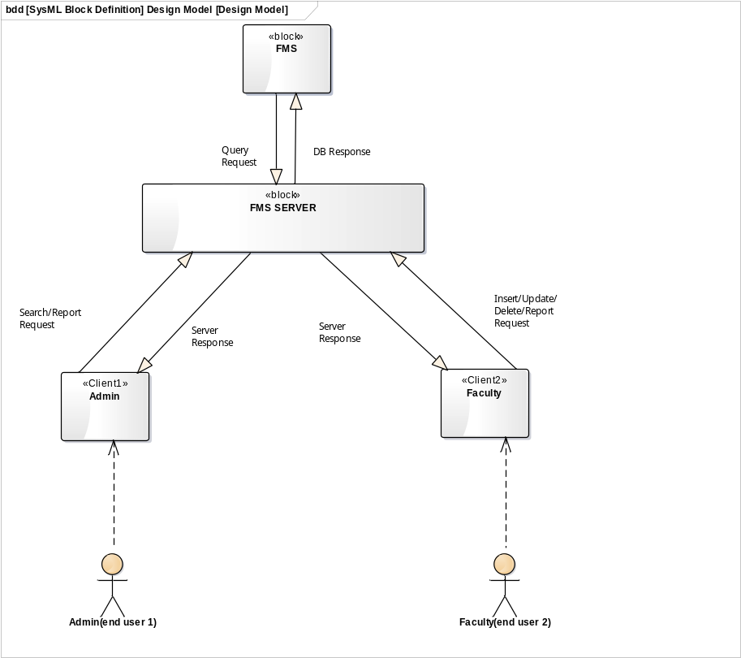
Fig: 3.2 System Architecture
Fig. 3.2.1 System Architecture
3.4 Database Design
3.4.1 Entity Relationship Diagram
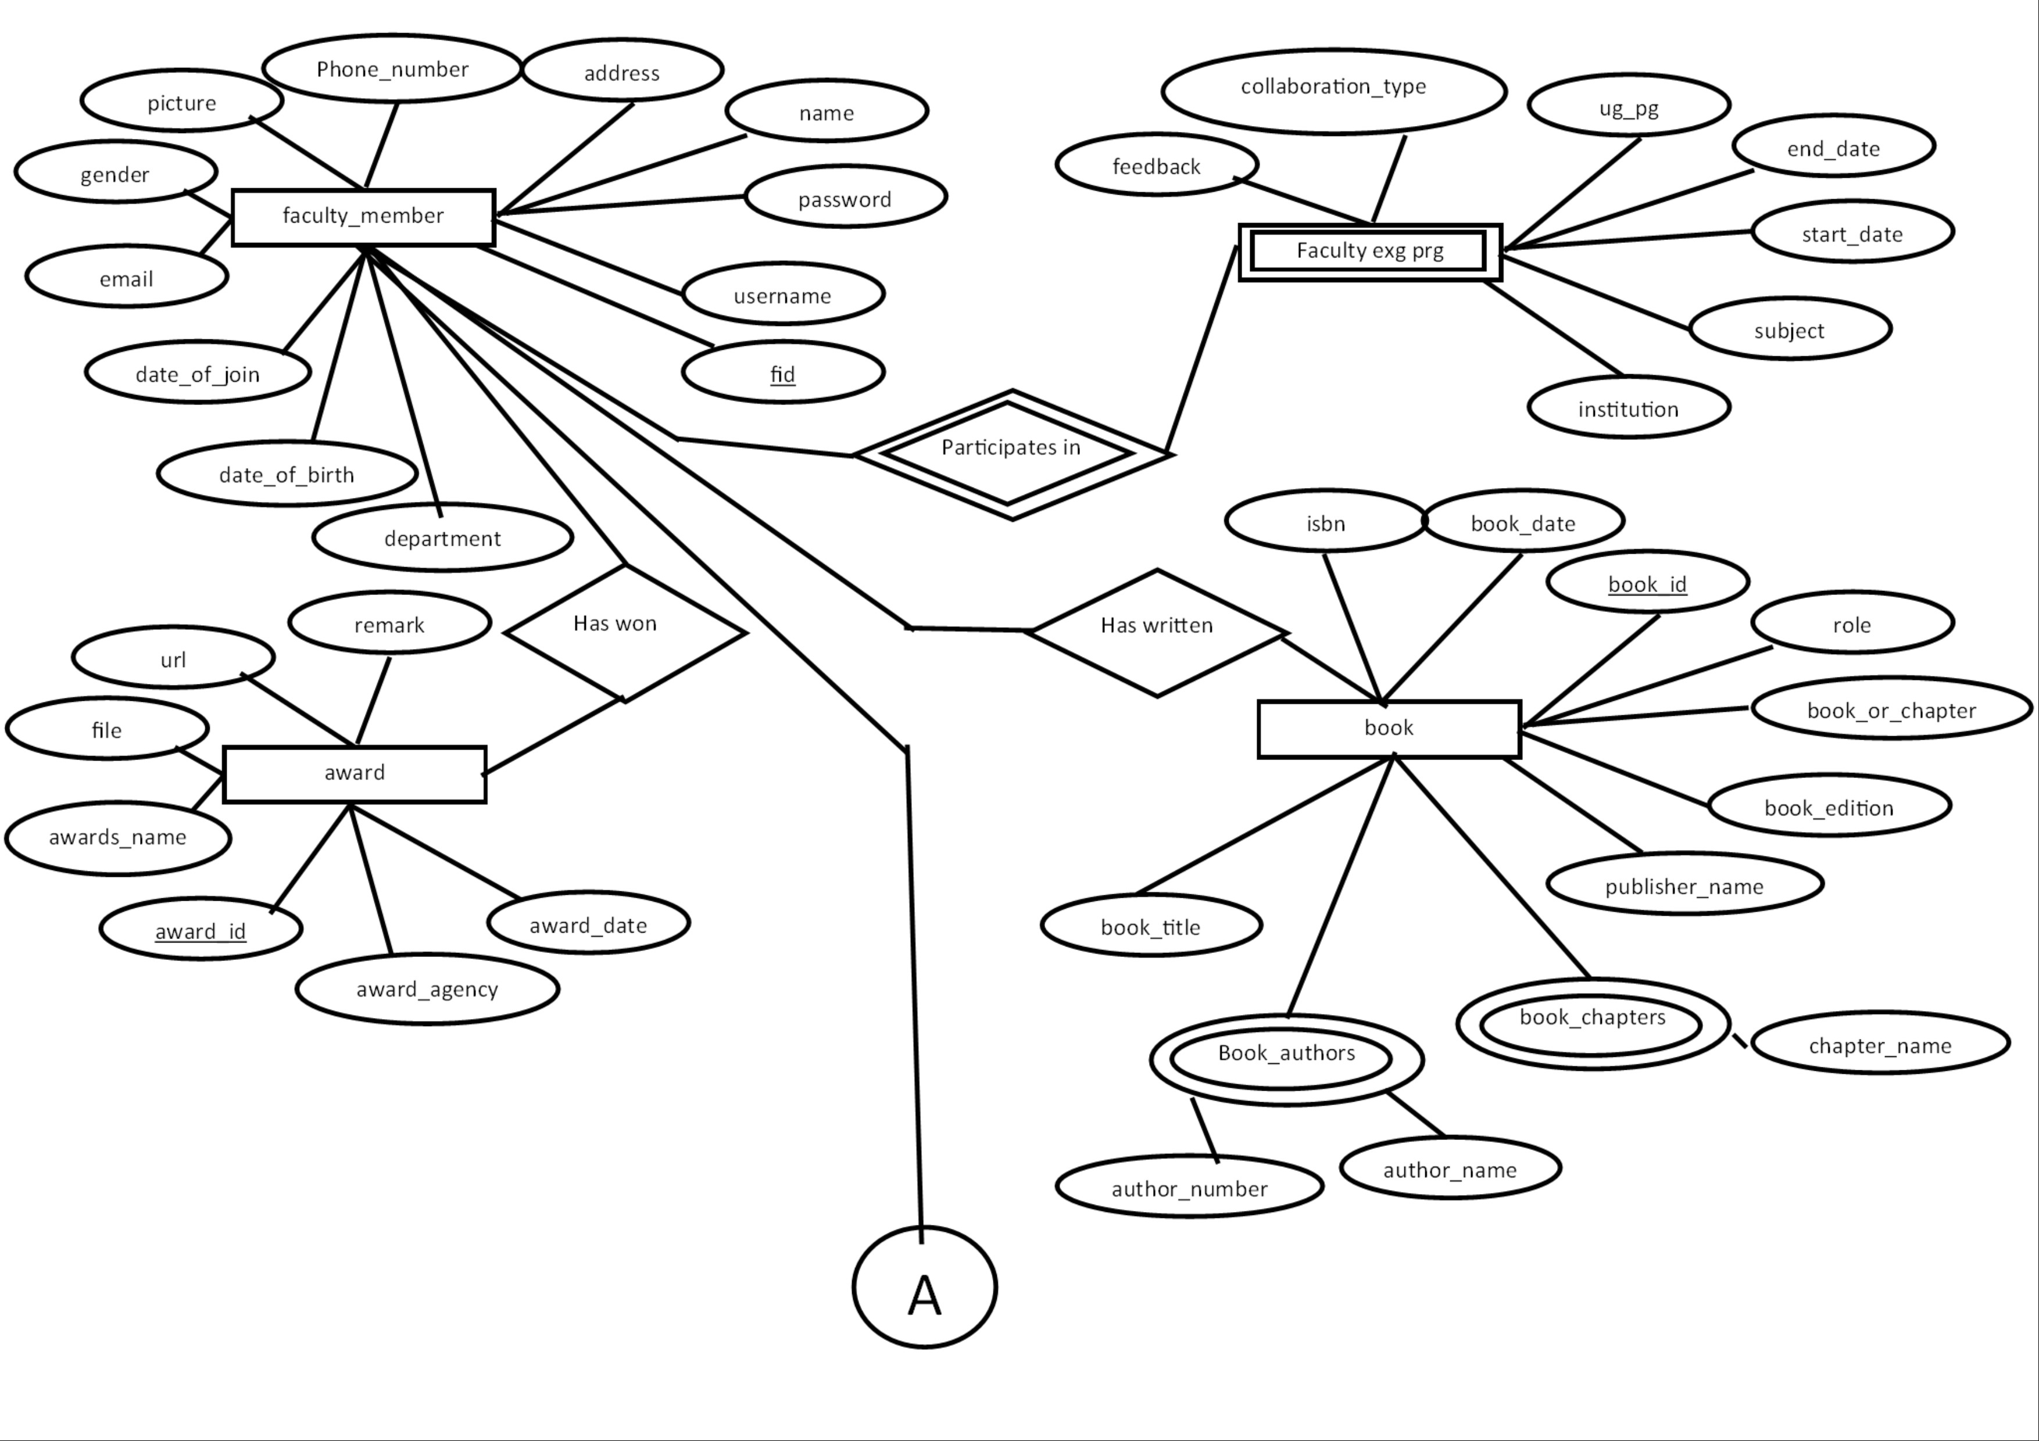
Fig. 3.4.1.1 E-R Diagram
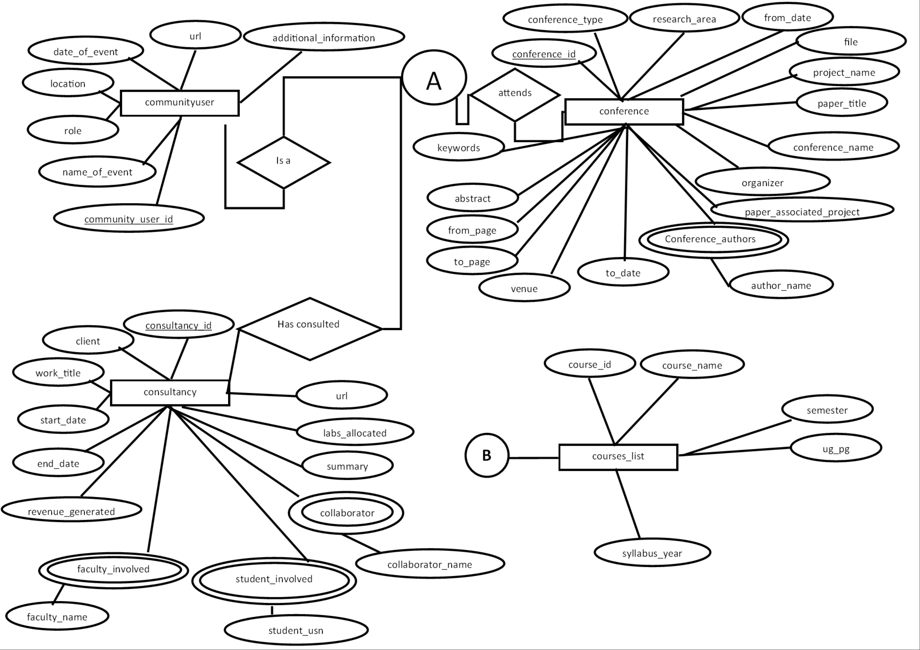

Fig. 3.4.1.2 E-R Diagram
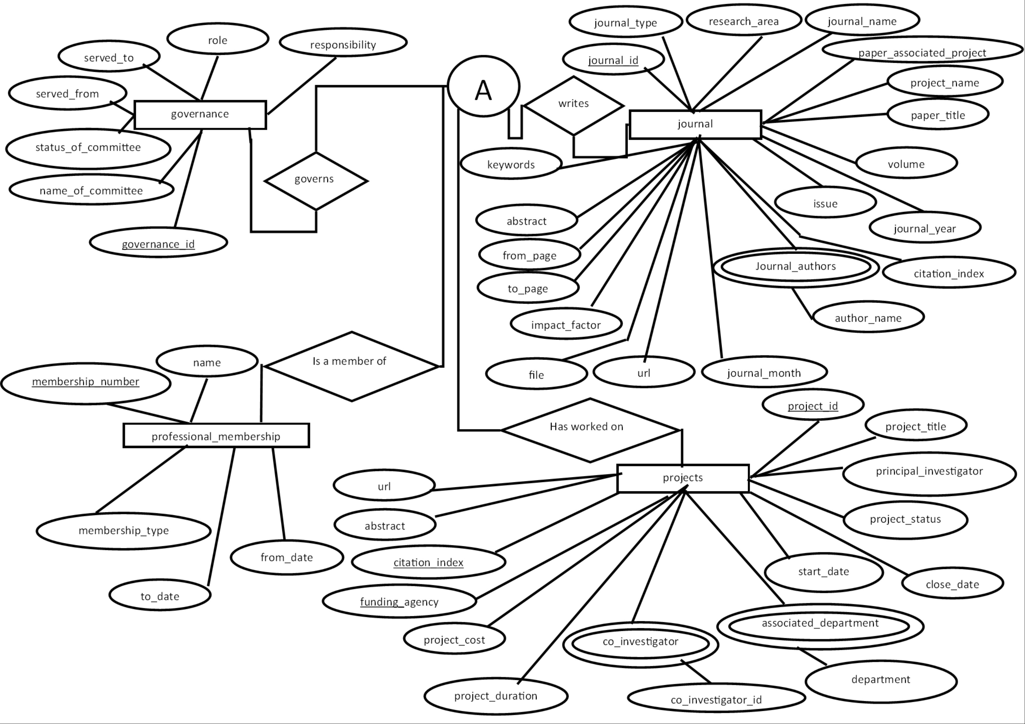
Fig. 3.4.1.3 E-R Diagram
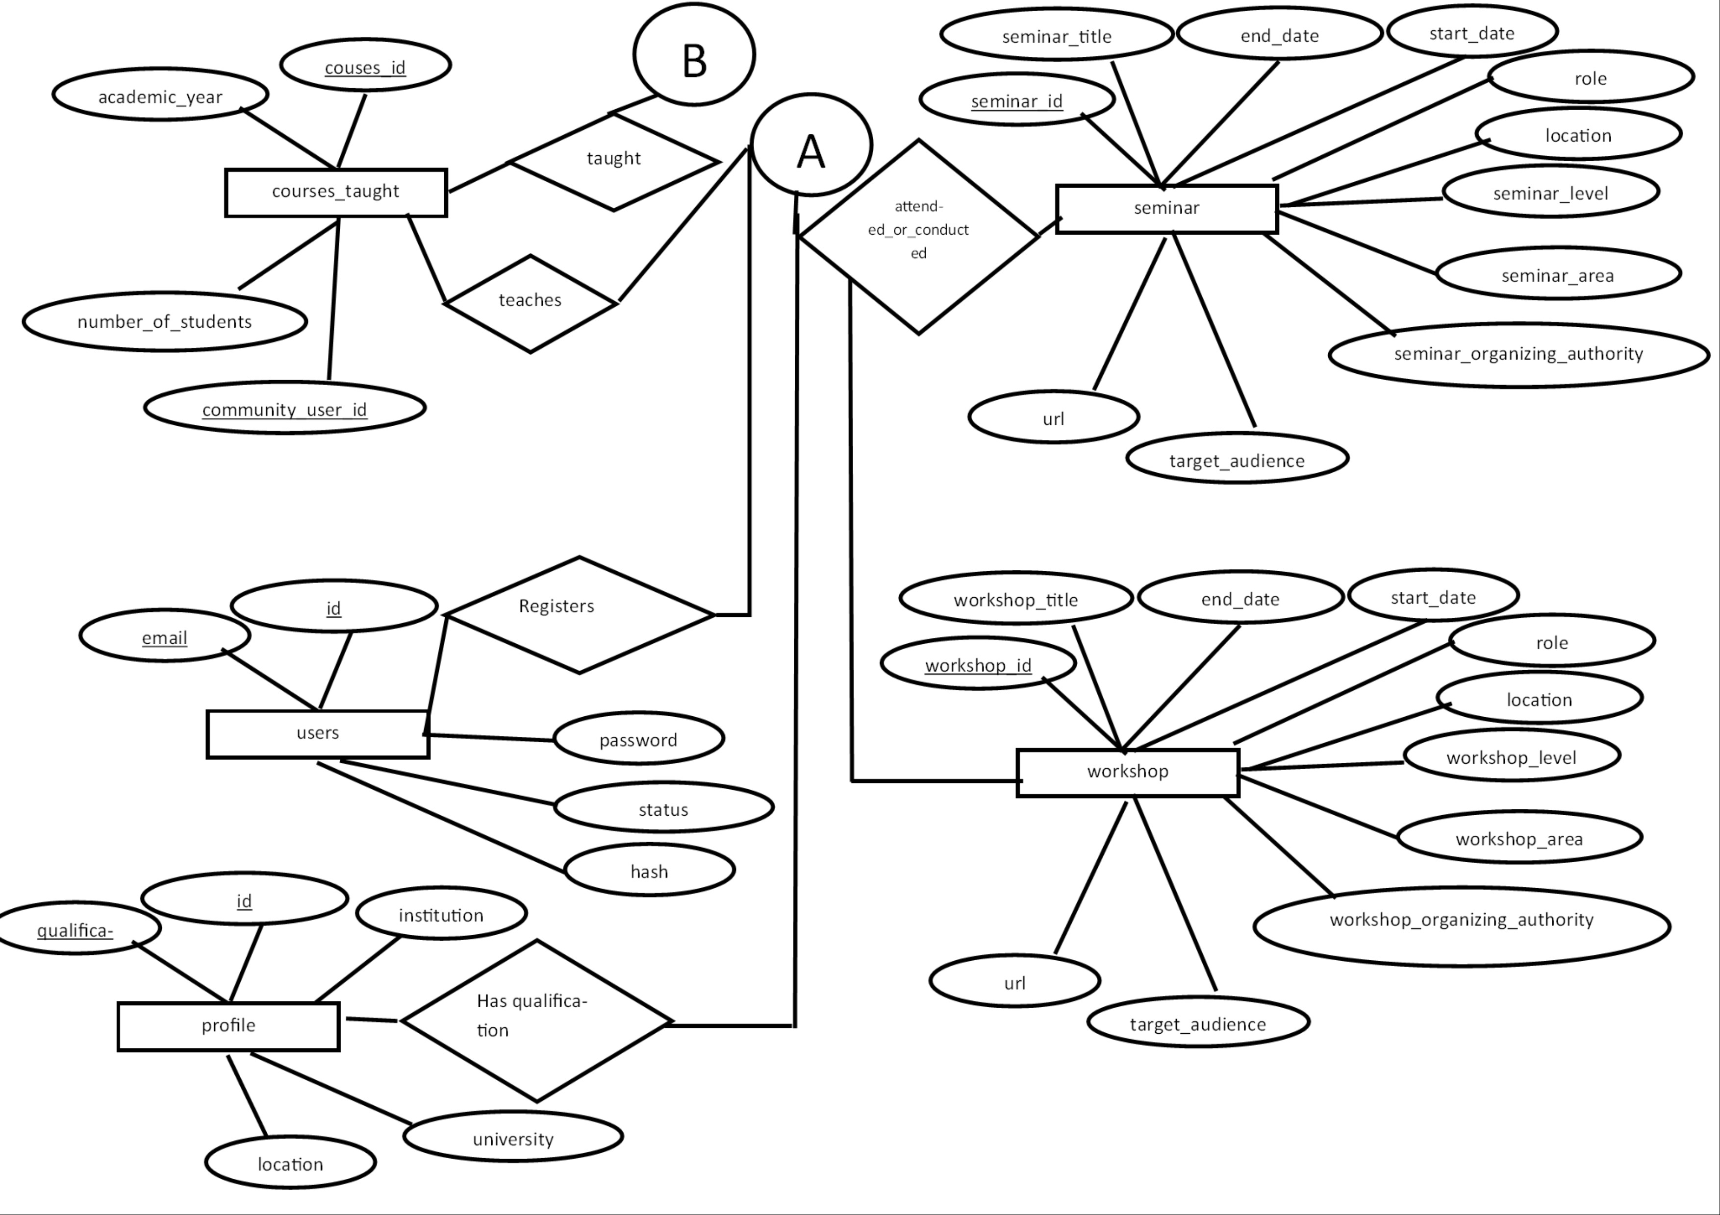
Fig. 3.4.1.4 E-R Diagram

3.4.2 Data Flow Diagram
3.4.2.1 Level 0 Diagram
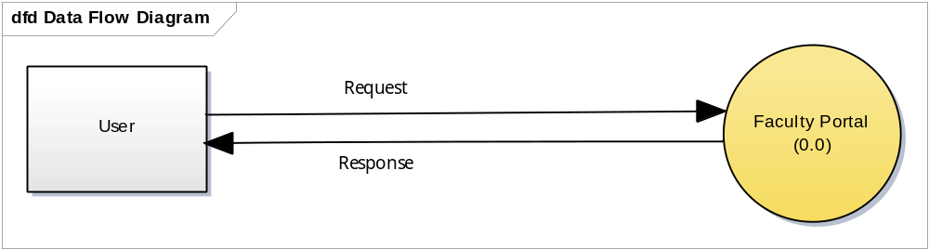
Fig:3.4.2.1 Data Flow Diagram Level 0

- The User sends a request which is to be authenticated which if allowed for that type of user and if that kind of request exists is allowed and converted into a query.
- If that requests is not authenticated, a response to the GUI or user end is generated for eg: validations on fields.
- Query hence is executed on the server side and an output is generated and displayed to the user.
3.4.2.2 Level 1 Diagram
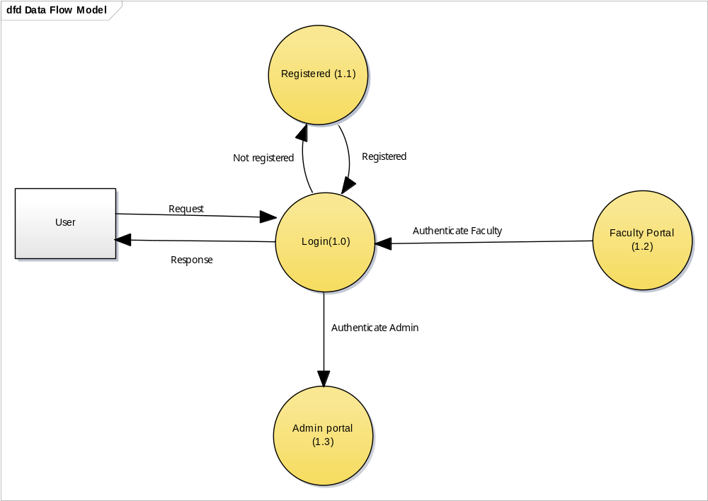
Fig:3.4.2.2 Data Flow Diagram Level 1

- The user enters the credentials.
- The credentials are checked and verified against the user registration.
- If the user is not registered, he is not authenticated.
- The appropriate view is displayed based on the access level of the user.

3.4.2.3 Level 2 Diagram
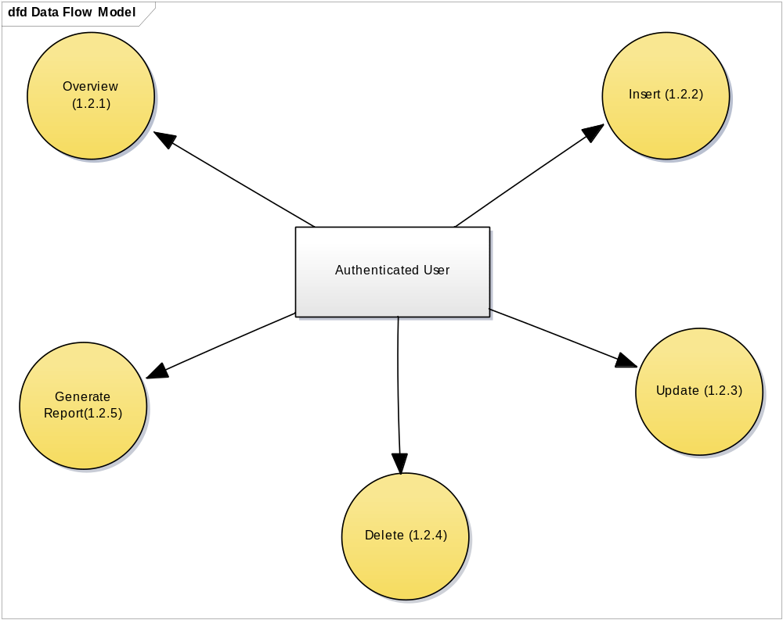
Fig3.4.2.3: Data Flow Diagram level 2
- The user, once he is authenticated, is presented with various views that he allows him to update and change data.
- The user also has views where he can overview the data and generate the report.

3.4.2.4 Level 3 Diagram
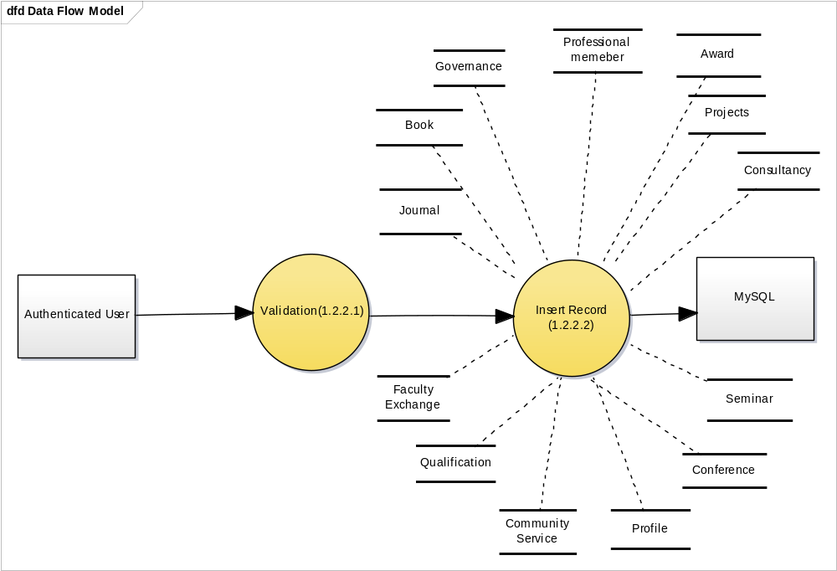
Fig3.4.2.4: Data Flow Diagram level 3

- The user is authenticated.
- Once the user is authenticated, he is validated and presented the insertion screen.
- There are various tables as mentioned in the DFD, in which user can insert data.
- Once the data is collected from the user, it is then inserted into mysql database.
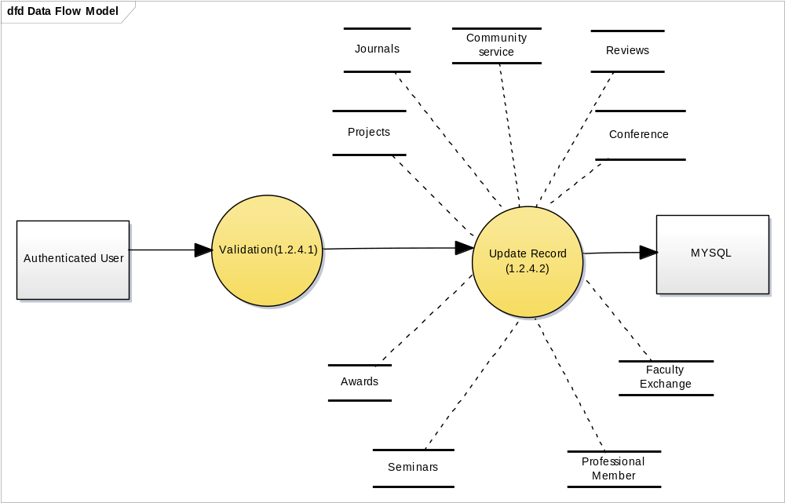
Fig:3.4.2.5: Data Flow Diagram level 3
- The user is authenticated.
- Once the user is authenticated, he is validated and presented the updation screen.
- There are various tables as mentioned in the DFD, in which user can update data.
- Once the data is collected from the user, it is then updated in mysql database.

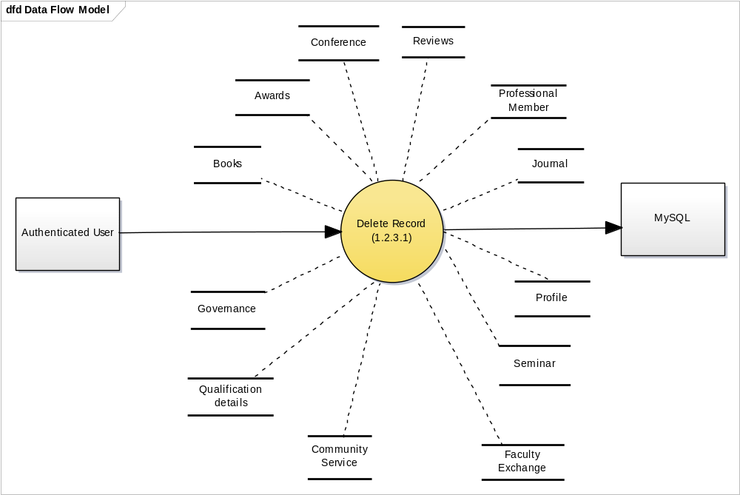
Fig 3.4.2.6: Data Flow Diagram level 3
- The user is authenticated.
- Once the user is authenticated, he is validated and presented the deletion screen.
- There are various tables as mentioned in the DFD, in which user can delete data.
- Once the data is collected from the user, it is then deleted from mysql database.

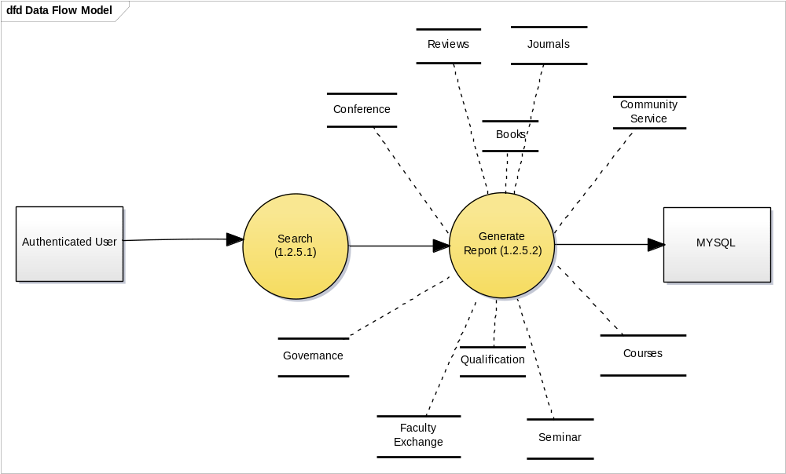
Fig3.4.2.7: Data Flow Diagram level 3
- The user is authenticated.
- Once the user is authenticated, he is validated and presented with the screen where he can specify filters to generate report.
- There are various tables as mentioned in the DFD, in which user can query information.
- Once the data is collected from the database, the user is presented with a report of the queried information.

